Test Automation

**Test automation is at the core of our testing strategy for digital transformation**

**What is Test Automation?**

The method which/that takes automation tool’s support to execute the test cases is known as Automation Testing.

**Goal of Automation**

Goal of Automation is to reduce number of test cases to be run manually and not eliminate manual testing all together.

**Why Automation?**

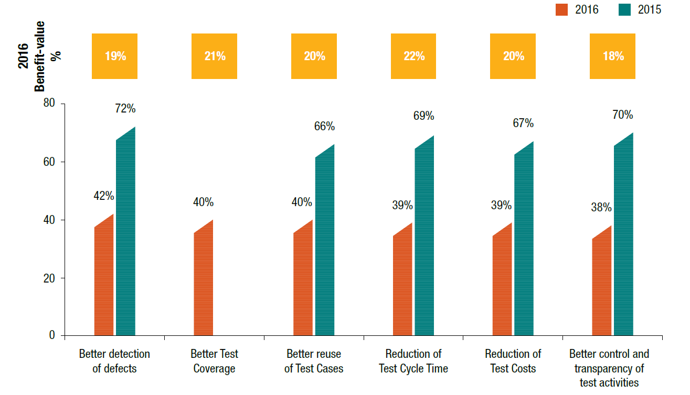

According to World Quality report of Capgemini, the most realized benefit of test automation is :

1. Better detection of defects (42%)
2. Better Test Coverage and Reuse of Test Cases (40%)
3. Reduction of Time Cycle & Test Cost (39%)
4. Better Control and transparency of Test (38%)

**What to Automate:**

1. High Risk - Business Critical test cases
2. Test cases that are executed repeatedly or for regression testing
3. Test Cases that are very tedious or difficult to perform manually
4. Test Cases which are time consuming

**What NOT to Automate:**

1. Test Cases that are newly designed and not executed manually at least once
2. Test Cases for which the requirements are changing frequently
3. Test cases which are executed on ad-hoc basis.

**Test Automation process:**

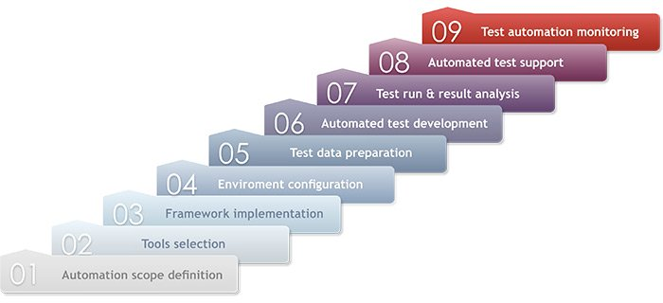

**How to choose Automation Tool?**

1. Support for various types of test - including functional, test management, mobile, etc...
2. Scripting Language Used
3. Support for multiple testing frameworks
4. Environment Support
5. Ability to recognize objects in any environment
6. Extensive test reports and results

**Automation Testing Tools:**

|  |  |  |
| --- | --- | --- |
| **Functional Testing Tool** | **Performance Testing Tool** | **Mobile Testing Tool** |
| **Selenium** | **Jmeter** | **Selendroid** |
| **QTP (HP UFT)** | **Load Runner** | **Appium** |
| **Rational Functional Tester** | **Rational Performance Tester** | **Robotium** |
| **Silk Test** | **Silk Performer** | **Calabash** |
| **QA Complete** | **Test Complete** | **Monkey Talk** |

**Note:**

Right selection of automation tool, testing process and team, are important players for automation to be successful. Manual and automation methods go hand-in hand for successful testing.